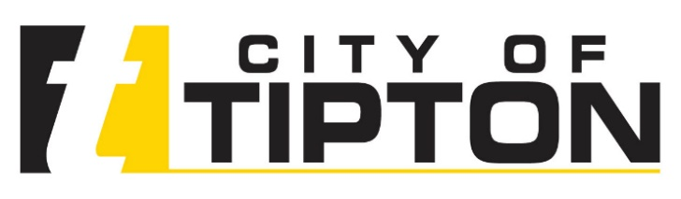

**August 18, 2020**

**To: Potential Respondents to the Tipton RFI for Community Wide Broadband Services**

**From: Curtis Dean, SmartSource Consulting**

**RE: RFI Addendum #1**

Curtis Dean, SmartSource Consulting

curtis@smartsourceconsulting.com

**The City of Tipton is providing the following addendum to the Request for Information (RFI) for Community Wide Broadband Services originally issued on July 22, 2020.**

The derecho that struck Iowa on August 10, 2020 caused widespread devastation, including to vital infrastructure such as the electric grid and telecommunications. In order to provide firms that may have been affected with additional time to prepare their respondents, **the City is hereby amending the deadline for submission to Friday, October 9, 2020 at 5:00pm CT.**

The amended timeline is listed below.

|  |  |
| --- | --- |
| Issuance of Request for Information | June 26, 2020 |
| Possible Addendum posted to City of Fort Dodge website | July 31, 2020 |
| **RFI Responses Due** | **October 9, 2020, 5:00pm CT** |
| **Discussion Period Starts** | **October 10, 2020** |
| Report to City Council | To be determined |

If you have any questions about this addendum, feel free to contact Curtis Dean at SmartSource Consulting at (515) 650-0251 or at the email listed below.